YORK COLLEGE/City University of New York 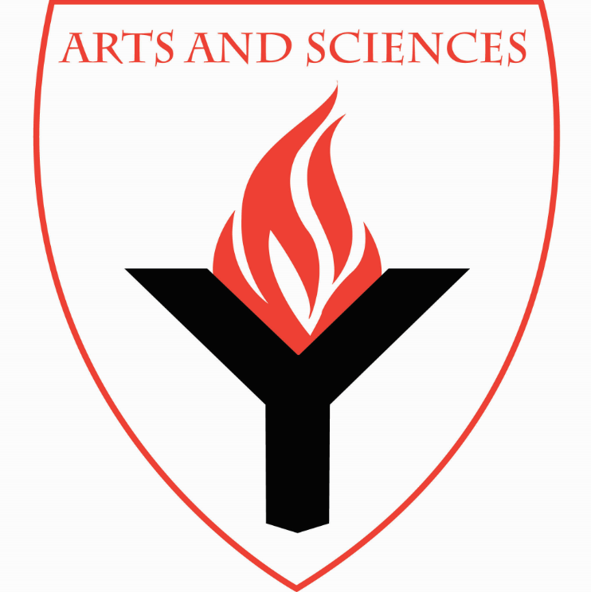 Department of History, Philosophy, and Anthropology, School of Arts and Sciences

Initiation Ceremony of The Tau Lambda Chapter
Phi Alpha Theta - The National Honor Society in History

Keynote Speaker – Dr. Roberto Benedito, Assistant Professor/Coordinator of Anthropology, York College. He will be discussing Impeachment Proceedings: A Comparative Study of Nigeria and the Philippines

Tuesday, May 7, 2019 * 4:30 to 5:50 p.m. * Room AC-4M07

All are welcome! Light Refreshments

