Library Committee
Meeting of Tuesday, November 6
Room 2A15

Attendees:
Andrea Silva (f), Kesi Gordon (s), Yong Kyu Lee (f), Kim Glickman (f), Helene DePalma (f), Peter Tighe (a), Meredith Powers (f)
- Meeting called to order at 11:15am, and SGA rep Kesi Gordon joined shortly afterwards, and we maintained a quorum until adjournment at 11:55am.
- Peter Tighe suggested an amendment of language for the April 19 2018 meeting minutes to specify that any future keycard access plans would also require the concurrence of Public Safety.
- New Business
  - Motion to approve April 19 2018 minutes with amendments:
    - Motioned by Helene DePalma
    - Seconded by Kim Glickman
    - In favor: unanimous
  - Report on IT updates
    - Peter Tighe reported that 2 printers and 3 scanners were added to the library. He has already looked at paper use over the Spring 2018 semester, and will compare Fall 2018 with Fall 2017 paper use when the semester ends to see if the scanners have reduced student printing.
    - There are a few issues with the high school network logins, which requires communication with the high school IT department.
    - Additionally, the PC reservation system is in vendor contract renegotiation and rebidding, so any communication with the vendor is on hold until the contract is resolved. It is currently in the procurement stage.
  - Report on the library budget:
    - Meredith Powers reported the grim FY2018-2019 budget situation for the Library. Currently, the Library has been allocated $17,776 for books and book-related contractual services, $9000 of which is for books only (including physical and ebooks). To put into context, the book budget for last year FY2017-2018 was $68,161. Even that figure is down from previous year’s spending: FY2016-2017 had a book budget of $119,586 and FY2015-2016 had $118,360. While we know that budget cuts have affected all departments across the board, the Library department is seriously concerned about maintaining the quality, currency, and relevance of the collection. Meredith Powers also shared some charts comparing York’s spending per FTE with other senior CUNY colleges, and they are attached here:
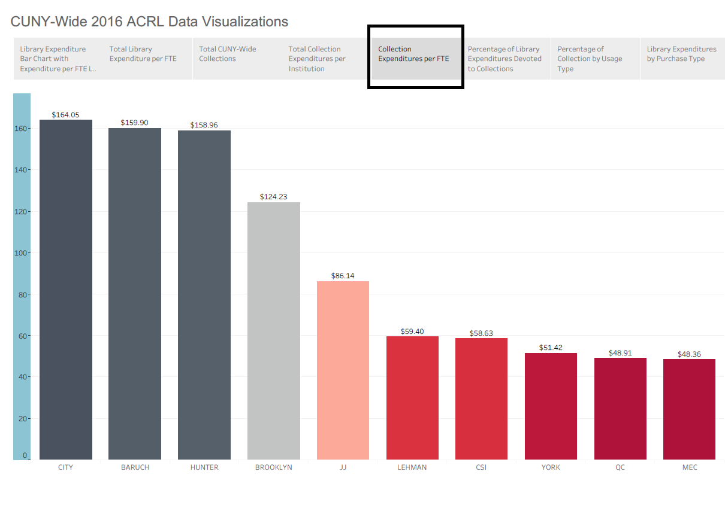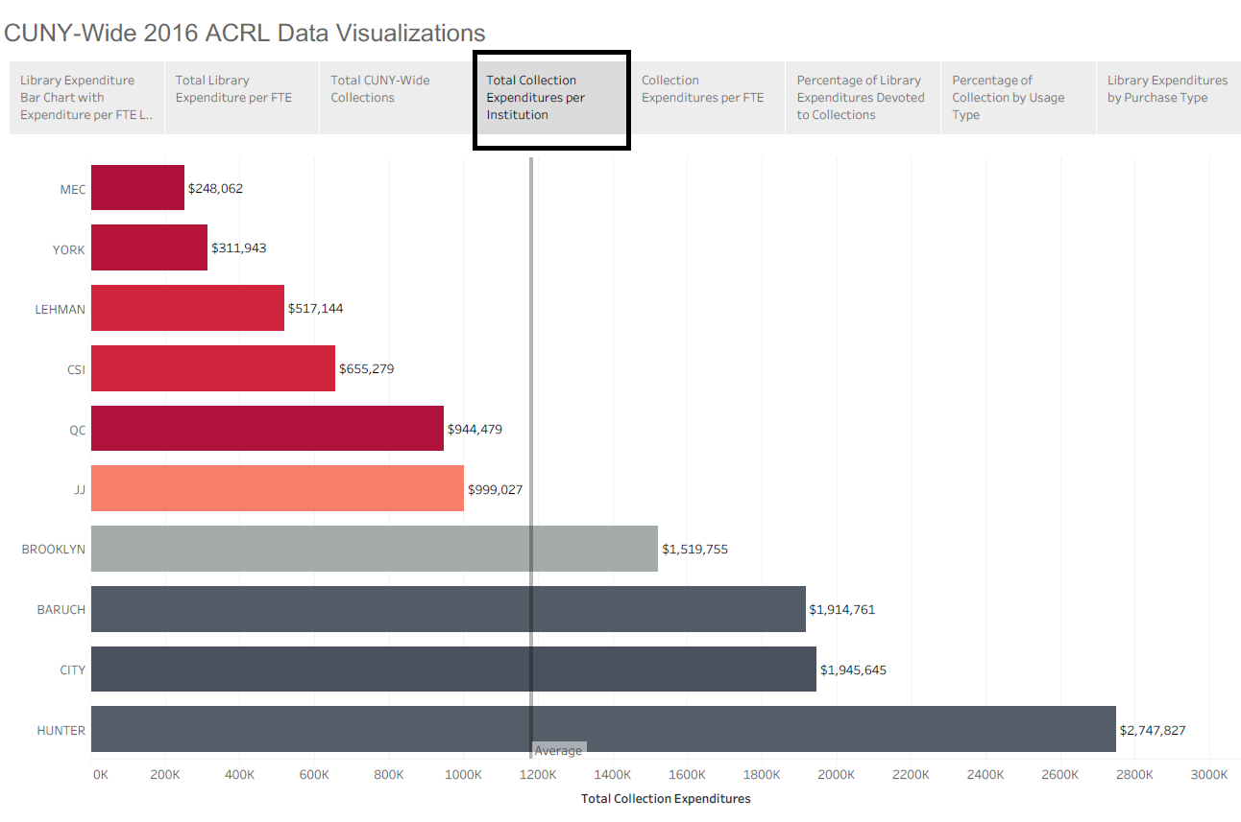
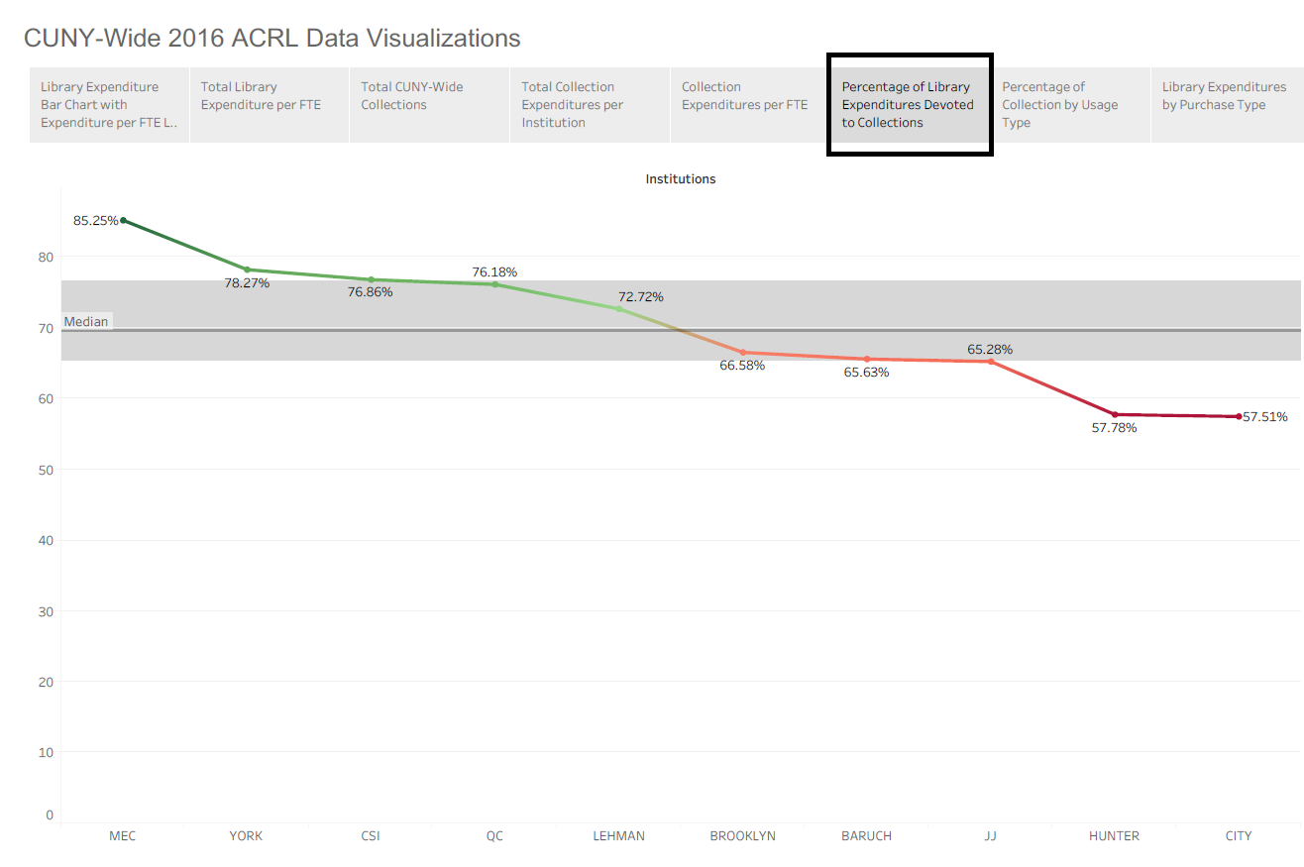
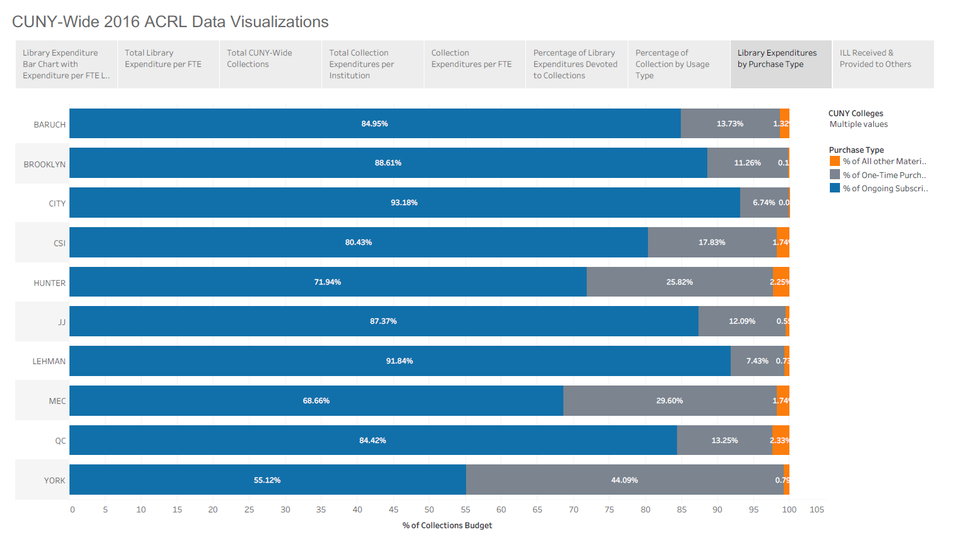

  - Printers in the library
    - Peter Tighe reported on the current status of printers and scanners in the library – there are 5 scanners and several new printers on the 3rd floor. As the new computers from the Student Government purchase last year are installed on the 2nd and 3rd floors, IT would like to add printers downstairs as well to fully complement the services on both levels. There are about 30-40 computers going in on the 2nd floor, and a similar number for the 3rd floor.
  - Elections of Chair and Secretary for Fall 2018/Spring 2019
    - Since we didn’t have a student representative at the April 19 2018 meeting, our elections were invalid. Additionally, Daniel Phelps--who was planning to serve as Secretary—is actually not serving this year as his term expired.
    - Helene DePalma nominates Andrea Silva for Chair and Kim Glickman seconds. Unanimous support.
    - Meredith Powers self-nominates for Secretary and Andrea Silva seconds. Unanimous support.
  - Reports to the Senate
    - Meredith Powers offers to email Bill Ashton to find out about getting on the agenda for the next Senate meeting, and will report back to CLT with dates – we will decide who will report our concerns about the library budget to the Senate when we know the date.
  - Adjournment
    - Andrea Silva moves and Peter Tighe seconds. Unanimous assent. Meeting adjourns at 11:55am.

