Enrollment & Retention Management Update – October 2025
10/5/2025

Dear Campus Community,

Please find attached the Enrollment & Retention Management Update for October 2025. In addition to reporting enrollment targets, we are also providing a list of important dates and recruitment activities. Feel free to reach out if you have any questions or need more information.

Enrollment:
Below are the final enrollment numbers for Fall 2025 as of Sept. 30, 2025.
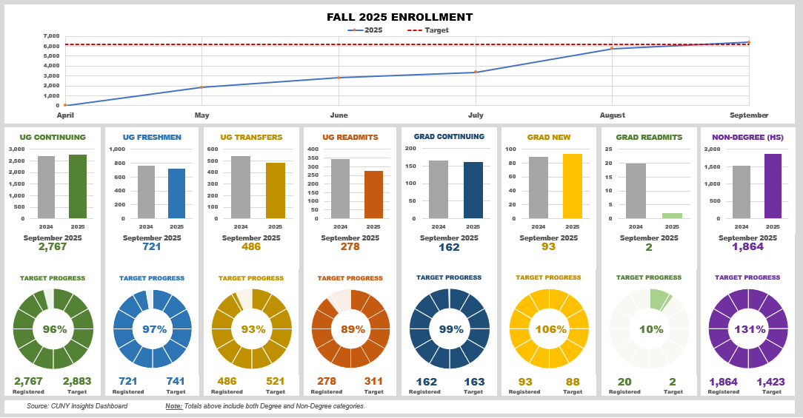

Spring 2026 Enrollment Targets
Enrollment and Retention Management is projecting a modest 3% increase in enrollment for Spring 2026. Below are the enrollment numbers for Spring 2025 and targets for Spring 2026.
 | Spring 2025 FORM A | Spring 2026
 | Enrolled | TARGET
UG Continuing | 3,382 | 3,432
UG Freshmen | 82 | 130
UG Transfers | 275 | 300
UG Readmits | 187 | 207
UG TOTAL | 3,923 | 4,069
GRAD Continuing | 195 | 195
GRAD New | 8 | 11
GRAD Readmit | 2 | 4
GRAD TOTAL | 205 | 210
TOTAL DEGREE | 4,128 | 4,279
NONDEG (HS) | 1,762 | 1,700
TOTAL NONDEG | 1,762 | 1,700
TOTAL | 5,890 | 5,979

Enrollment and Retention Changes:
Enrollment Appointments – Effective Spring 2026 we will no longer be utilizing enrollment appointments. Students can register at any time during open registration.
Admissions Application Fee - CUNY is waiving the Admissions Application Fee. See dates below:
- New York City Public Schools (NYCPS) - Oct. 27 - Nov. 21
- Non-NYCPS including Yeshivas and Private schools - Nov. 11 - Nov. 21
Readmission Fee - the college is waiving the $20 readmission fee for Spring 2026 to remove that financial barrier for students who wish to return.
Office Moves – Admissions Office will move into the Advisement space to provide more synergy with the Welcome Center and share staffing resources.
The Advisement Center will move into the Admissions Office. Their new location on the first floor will complete our Student Services Resource HUB by having Registrar, Financial Aid and Bursar in close proximity.
V-READY – Virtual Registration, Enrollment and ADvisement at York – students will be able to register via virtual appointments on zoom. Transfer Tuesday and Freshmen Friday will kick off this new process the week of October 27th.

Winter 2025 & Spring 2026 Registration Information:
Wednesday, October 1, 2025
The Schedule of Classes for Winter 2025 & Spring 2025 will be available and students can begin to place courses in their shopping cart on Schedule Builder.
Wednesday, October 1 – Friday, October 3, 2025 – Advisement Stops (ADV)
ADV stops will be placed on all incoming students for Spring 2026.
Monday, October 6, 2025 – Priority Registration
Continuing Students in Special Programs can begin to register for classes.
Tuesday, October 7, 2025 – General Registration
All Continuing Students can begin to register for classes.
Tuesday, October 28, 2025 – Transfer Tuesday
New Transfer students will be invited BY APPOINTMENT to be advised and registered for classes through our V-READY process.
Friday, October 31, 2025 – Freshmen Friday
New Freshmen students will be invited BY APPOINTMENT to be advised and registered for classes through our V-READY process.

Important Dates:
Wednesday, Oct. 1 | No classes scheduled
Wednesday, Oct 1 | Schedule of Classes available to view on Global Search
Thursday, Oct. 2 | No classes scheduled
Friday, Oct. 3 | All ADV stops will be active for Spring 2026
Monday, Oct. 6 | Winter and Spring 2026 - Priority Registration
Tuesday, Oct. 7 | Winter and Spring 2026 - Open Registration
Tuesday, Oct. 7 | Midterm Assessment Period
Wednesday, Oct. 8 | Midterm Assessment Period
Thursday, Oct. 9 | Midterm Assessment Period
Friday, Oct. 10 | Midterm Assessment Period
Saturday, Oct. 11 | Midterm Assessment Period
Sunday, Oct. 12 | Midterm Assessment Period
Monday, Oct. 13 | College Closed - No classes scheduled
Monday, Oct. 13 | Midterm Assessment Period
Tuesday, Oct. 14 | Midterm Assessment Period
Tuesday, Oct. 14 | Classes follow a MONDAY schedule
Wednesday, Oct. 15 | Midterm Assessment Period
Monday, Oct. 20 | No classes scheduled
Friday, Oct. 24 | Classes follow a MONDAY schedule
Monday, Oct. 27 | Admissions Application Fee is waived through Nov. 21 for NYC Public schools
Tuesday, Oct. 28 | Transfer Tuesday – new Transfer Student Registration (V-READY)
Thursday, Oct. 30 | Pumpkin Decorating Contest – 2pm @ Cafeteria (Cash Prizes)
Friday, Oct. 31 | Freshmen Friday – new Freshmen Student Registration (V-READY)

Recruitment Events
October Events – We encourage faculty, staff, and alumni to join the Admissions Counselors on all recruitment events listed below. If you are interested in participating, please contact Anthony Davis at adavis13@york.cuny.edu

Date | Time | Name of Event
Wednesday, October 1, 2025 | 11:50 AM | East Side Community School
Thursday, October 2, 2025 | 7:00 PM | The Mary Louis Academy
Thursday, October 2, 2025 | 6:00 PM | St. Vincent Ferrer High School
Thursday, October 2, 2025 | 9:30 AM | Archbishop Stepinac High School
Friday, October 3, 2025 | 8:30 AM | 2025 Fall CUNY Counselor Conference
Saturday, October 4, 2025 | 12:00 PM | EMH’s 4th Annual Southeast Queens College Fair
Saturday, October 4, 2025 | 12:00 PM | Latin Resource Festival: Roots & Culture
Monday, October 6, 2025 | 7:00 PM | Holy Cross High School
Monday, October 6, 2025 | 8:30 AM | Fordham Leadership Academy
Tuesday, October 7, 2025 | 8:00 AM | Herbert H. Lehman High School Post Secondary Fair
Wednesday, October 8, 2025 | 3:00 PM | Veterans Outreach Day
Wednesday, October 8, 2025 | 12:00 PM | Bishop Loughlin Memorial High School
Wednesday, October 8, 2025 | 10:00 AM | East Side Community School
Wednesday, October 8, 2025 | 9:30 AM | Mosholu Montefiore Community Center
Thursday, October 9, 2025 | 6:00 PM | Queens Borough President's Office and Queens Presidents' High School Council
Thursday, October 9, 2025 | 5:00 PM | August Martin High School
Thursday, October 9, 2025 | 4:00 PM | William Cullen Bryant High School
Thursday, October 9, 2025 | 12:00 PM | Abraham Lincoln High School
Thursday, October 9, 2025 | 9:00 AM | UFT College Fair
Friday, October 10, 2025 | 11:00 AM | Robert F Wagner JR. SSAT College Fair
Friday, October 10, 2025 | 9:00 AM | Franklin K. Lane Pathways Fair
Tuesday, October 14, 2025 | 11:00 AM | Westchester Community College Fall 2025 Transfer Fair
Wednesday, October 15, 2025 | 5:00 PM | Cambria Heights Academy College Fair
Wednesday, October 15, 2025 | 2:00 PM | City-As-School Fall 2025 College and Career Fairs
Wednesday, October 15, 2025 | 10:00 AM | Bayside High School
Wednesday, October 15, 2025 | 10:00 AM | NYPL College Fair
Wednesday, October 15, 2025 | 10:00 AM | VOYAGES Preparatory High School College Fair
Wednesday, October 15, 2025 | 9:30 AM | St. Raymond High School for Boys
Wednesday, October 15, 2025 | 9:15 AM | Franklin Delano Roosevelt High School
Wednesday, October 15, 2025 | 8:00 AM | College Bound Initiative (CBI) Bronx-Wide College Fair at Mercy University Campus in the Bronx
Thursday, October 16, 2025 | 6:00 PM | Harry S Truman College Fair
Thursday, October 16, 2025 | 6:00 PM | Benjamin N Cardozo High School
Thursday, October 16, 2025 | 6:00 PM | Summit Academy Charter School
Thursday, October 16, 2025 | 3:30 PM | Innovation Charter High School
Thursday, October 16, 2025 | 2:30 PM | City-As-School Fall 2025 College and Career Fairs
Thursday, October 16, 2025 | 12:00 PM | Roosevelt High School
Thursday, October 16, 2025 | 11:30 AM | Collegiate Institute for Math and Science
Thursday, October 16, 2025 | 10:30 AM | Queens EOC College Fair
Thursday, October 16, 2025 | 10:30 AM | QIRT College & Career Fair 2025
Thursday, October 16, 2025 | 9:30 AM | Forest Hills High School College & Career Fair
Friday, October 17, 2025 | 10:30 AM | East Williamsburg Scholars Academy
Saturday, October 18, 2025 | 10:30 AM | KIPP NYC College Prep’s Annual College and Career Fair
Saturday, October 18, 2025 | 9:00 AM | Girls in Aviation Day 2025 - Aviation High School
Tuesday, October 21, 2025 | 6:00 PM | St. Edmund Preparatory High School
Tuesday, October 21, 2025 | 1:00 PM | BMCC Transfer Fair
Tuesday, October 21, 2025 | 11:00 AM | Hostos Community College Fall 2025 Transfer Fair
Tuesday, October 21, 2025 | 10:00 AM | Career Council/National Hispanic Fair
Wednesday, October 22, 2025 | 12:00 PM | Uncommon Collegiate Charter High School
Wednesday, October 22, 2025 | 11:00 AM | Fall 2025 Transfer Fair at KCC
Wednesday, October 22, 2025 | 10:00 AM | Future Pathways Expo at VOYAGES Preparatory High School
Wednesday, October 22, 2025 | 9:15 AM | New Heights Academy Charter School
Wednesday, October 22, 2025 | 9:00 AM | Thomas Jefferson Educational Campus
Thursday, October 23, 2025 | 5:30 PM | 2025 STEM College Fair at NYSCI
Thursday, October 23, 2025 | 4:00 PM | Queens South HS
Thursday, October 23, 2025 | 11:00 AM | CUNY LaGuardia Community College Fall 2025 Transfer Fair
Thursday, October 23, 2025 | 10:00 AM | Richmond Hill High School Fall 2025 Postsecondary Fair
Thursday, October 23, 2025 | 8:00 AM | Hillcrest HS College Fair
Friday, October 24, 2025 | 10:00 AM | Career Council/National Hispanic Fair
Friday, October 24, 2025 | 10:00 AM | Mathematics, Science Research & Technology (MAST) High School
Friday, October 24, 2025 | 8:30 AM | 2025 Fall CUNY Counselor Conferences
Saturday, October 25, 2025 | 12:00 PM | MBPO College Fair
Saturday, October 25, 2025 | 10:00 AM | AOFE College and Career Day
Monday, October 27, 2025 | 10:30 AM | Progress High School
Monday, October 27, 2025 | 10:15 AM | Robert H Goddard High School for Comm Arts 7 & Tec
Tuesday, October 28, 2025 | 5:00 PM | George Washington YABC
Tuesday, October 28, 2025 | 12:00 PM | College & Career Fair at Manhattan Comprehensive
Wednesday, October 29, 2025 | 12:15 PM | Frank McCourt High School
Wednesday, October 29, 2025 | 12:00 PM | Earl Monroe Basketball High School
Wednesday, October 29, 2025 | 9:00 AM | Chelsea Career and Technical Education High School
Thursday, October 30, 2025 | 5:30 PM | College and Career Fair at the High School for Arts and Business
Thursday, October 30, 2025 | 5:30 PM | Long Island City High School
Thursday, October 30, 2025 | 1:00 PM | Guttman Community College
Thursday, October 30, 2025 | 10:00 AM | Razi School / 2025 College Fair
Friday, October 31, 2025 | 8:30 AM | 2025 Fall CUNY Counselor Conference

