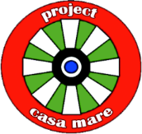

ADDENDUM

The Third York College Interdisciplinary Summer Semester Expedition
in the Republic of Moldova

Detailed Schedule of Activities

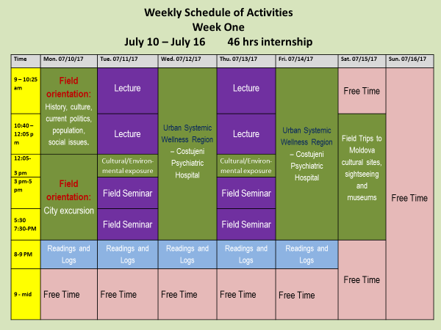
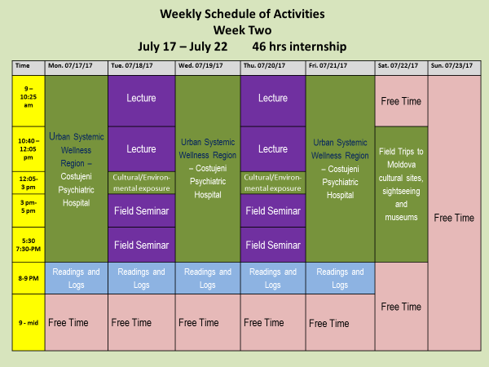

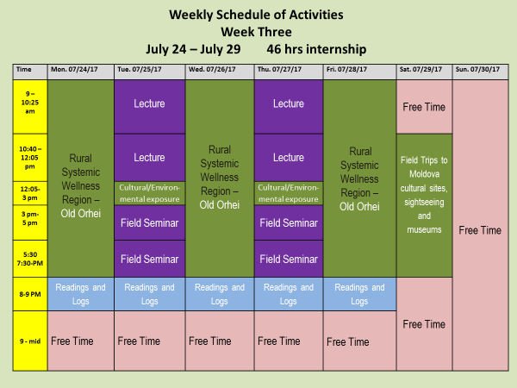

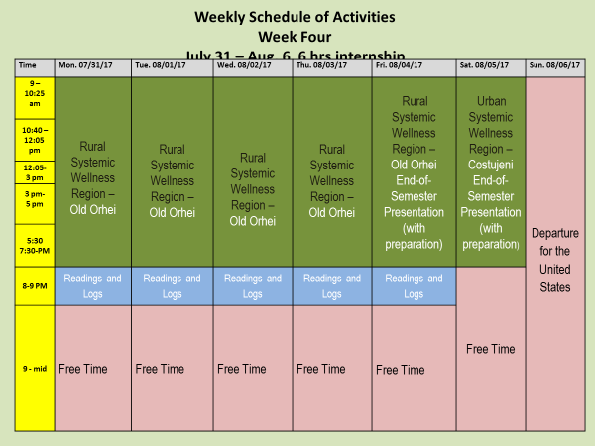

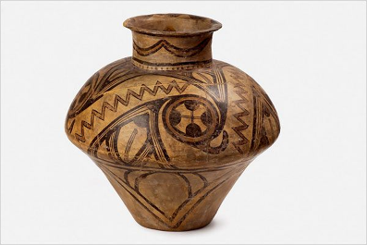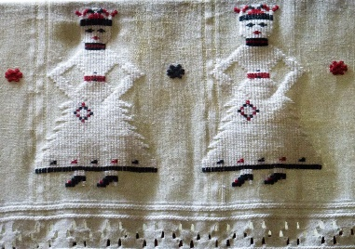

The Systemic Wellness Community Improvement Model methodology is predicated on the following
Assumptions and Principles:
On work and human nature
*The desire to work collectively toward the common goal represents an essential human need for meaningful vocational activities
*Meaningful work must include a comprehensive utilization of human physicality and the entire sensory spectrum
*Meaningful work must produce tangible outcomes that are accessible to the entire spectrum of sensory perception
*Meaningful work is directed toward the dual purpose of community improvement and personal growth
*Meaningful work is sustainable through the skills dissemination among community members and development of the lasting infrastructure for skills utilization.

On systemic wellness
*A distinct geographic community (e.g. village, small town, neighborhood) is the optimal arena of effective community organizing toward wellness
*Wellness is a systemic concept that concerns all community members and includes the following collective aspects of human existence: community infrastructure; functional health of individual community members; economy; security; and ecology.
*The lack of social cohesion that is based on culture/history is among the major causes of community degradation.
*The systemic interconnection with global conflicts, problems, and diseases is among major causes of community degradation.
*A beneficent intervention from abroad that is based on fascination with local culture/history is an effective methodology of community organizing toward an improvement in systemic wellness.

On community development
Community development has to be:
*approached multi-dimensionally
*planned as a social enterprise on the academic/theoretical/methodological platform
*economically viable
*propelled by community members' buy-in
*implemented through coordinated efforts of the broad national and international spectrum of stakeholders
*assessed through attainable, sustainable, and measurable outcomes.

On the Systemic Wellness Improvement Model
*The Systemic Wellness Improvement Model methodology identifies culture/history as the basic social glue that keeps community together.
*Deeper understanding of one’s history and richer cultural expression can be stimulated by the interest from outside the community, i.e. through the foreign project partners.
*Manufacture of replicas of historical artefacts (e.g. archaeological finds) through the synthesis of traditional skills and contemporary technologies constitutes an optimal vocation, a best practice, and meaningful work
*An economically-viable local artisan industry can sustain itself through local utilization and global marketing of the products
*The foreign partner is consistently present in joining the community in attaining and sustaining project outcomes.

On social work role in systemic wellness improvement:
- Social workers are trained to approach social problems systemically
- They are uniquely equipped to deal with systemic community needs and challenges and capable of addressing community need in its full complexity.
- The social work knowledge base is interdisciplinary and they are trained on the master’s level to work across various disciplines and in collaboration with allied professions.
- Social entrepreneurship is the primary methodology of the social work profession.
- The coordinating and integrating role of social workers in social projects ensures effectiveness and sustainability.

